HOSPITAL MANAGEMENT SYSTEM USING POWER – BI ANALYSIS

A PROJECT REPORT
Submitted by

KARTHICK V[211420104121]
Kayam Karthik Reddy [211420104124]
Payyavula Pavan Kalyan [211420104182]

in partial fulfillment for the award of the degree of

BACHELOR OF ENGINEERING

in

COMPUTER SCIENCE AND ENGINEERING


PANIMALAR ENGINEERING COLLEGE
(An Autonomous Institution, Affiliated to Anna University, Chennai)

APRIL 2024

PANIMALAR ENGINEERING COLLEGE
(An Autonomous Institution, Affiliated to Anna University, Chennai)

BONAFIDE CERTIFICATE

Certified that this project report “HOSPITAL MANAGEMENT PROJECT WITH POWER – BI ANALYSIS” is the bonafide work of “Karthick V, Kayam Karthik Reddy, Payyavula Pavan Kalyan ” who carried out the project work under my supervision.

Signature of the HOD with date | Signature of the Supervisor with date
DR L.JABASHEELA M.E., Ph.D.,  HEAD OF THE DEPARTMENT | DR R. JOSPHINELEELA M.E., Ph.D.,  SUPERVISOR
PROFESSOR,  Department of Computer Science and Engineering,  Panimalar Engineering College, Chennai - 123 | PROFESSOR,  Department of Computer Science and Engineering,  Panimalar Engineering College, Chennai - 123

Certified that the above candidate(s) was examined in the End Semester Project Viva- Voce Examination held on ..............................

INTERNAL EXAMINER EXTERNAL EXAMINER

DECLARATION BY THE STUDENT
We Karthick V(211420104121), KayamKarthikReddy(211420104124) and Payyavula Pavan Kalyan(211420104182) hereby declare that this project report titled “HOSPITAL MANAGEMENT PROJECT WITH POWER – BI ANALYSIS”, under the guidance of Dr. R. Josphineleela M.E., Ph.D., is the original work done by us and we have not plagiarized or submitted to any other degree in any university by us.

Karthick V[211421104121]

Kayam Karthik Reddy[211421104124]

Payyavula Pavan Kalyan[211421104182]

ACKNOWLEDGEMENT
Our profound gratitude is directed towards our esteemed Secretary and Correspondent, Dr. P. CHINNADURAI, M.A., Ph.D., for his fervent encouragement. His inspirational support proved instrumental in galvanizing our efforts, ultimately contributing significantly to the successful completion of this project.

We want to express our deep gratitude to our Directors,

Tmt. C. VIJAYARAJESWARI, Dr. C. SAKTHI KUMAR, M.E., Ph.D., and
Dr. SARANYASREE SAKTHI KUMAR, B.E., M.B.A., Ph.D., for graciously affording us the essential resources and facilities for undertaking of this project.

Our gratitude is also extended to our Principal, Dr. K. MANI, M.E., Ph.D., whose facilitation proved pivotal in the successful completion of this project.

We express our heartfelt thanks to Dr. L. JABASHEELA, M.E., Ph.D., Head of the Department of Computer Science and Engineering, for granting the necessary facilities that contributed to the timely and successful completion of project.

We would like to express our sincere thanks to Dr. V. Subedha M.Tech., Ph.D., and Dr. R. Josphineleela M.E., Ph.D., and all the faculty members of the Department of CSE for their unwavering support for the successful completion of the project.

Karthick V[211421104121]
Kayam Karthik Reddy [21142104124]
PayyavulaPavanKalyan[211421104182]

ABSTRACT
The healthcare industry is increasingly leveraging digital technologies to enhance patient care and streamline hospital operations. Our project, a Hospital Management System (HMS) integrated with Power BI, aims to optimize healthcare administration by providing real-time data analytics and visualization. This system facilitates efficient patient record management, doctor scheduling, billing, and resource allocation, ensuring seamless hospital operations. Power BI integration enables data-driven decision-making by offering interactive dashboards, predictive analytics, and automated reporting. Additionally, mobile notifications for Power BI reports enhance accessibility, allowing stakeholders to stay updated on critical metrics. By implementing this data-driven hospital management approach, our project improves operational efficiency, enhances patient care, and supports evidence-based decision-making in healthcare institutions.This integrated Hospital Management System, enhanced by Power BI, transcends mere operational efficiency, fostering a paradigm shift towards strategic healthcare intelligence. It cultivates enhanced operational agility, enabling hospitals to adapt swiftly to fluctuating demands and resource availability, moving from reactive management to proactive planning. By transforming raw data into actionable insights, the system drives data-driven clinical excellence, empowering clinicians to make informed decisions that directly improve patient outcomes. Furthermore, it optimizes resource utilization, ensuring that assets are deployed effectively, minimizing waste, and supporting strategic planning. The system also refines stakeholder communication, creating a shared understanding of key performance indicators through intuitive visualizations. This, in turn, cultivates a culture of collaboration and alignment. Fundamentally, this HMS cultivates patient centricity, allowing healthcare providers to focus on delivering superior care, leading to enhanced patient experience.

 | LIST OF FIGURES
FIGURE NO. | FIGURE NAME | PAGE NO
1. | System Architecture | 23
2. | Level 0 Data Flow Diagram | 27
3. | Level 1 Data Flow Diagram | 28
4. | Level 2 Data Flow Diagram | 29
5. | UseCase Diagram | 30
6. | Class Diagram | 31
7. | Activity Diagram | 32
8. | Sequence Diagram | 33

LIST OF ABBRIVIATION
S.NO. | ABBREVIATION | DEFINITION
1. | HMS | Hospital Information System
2. | BI | Business Intelligence
3. | BP | Blood pressure
4. | ADT | Admission, Discharge, Transfer
5. | HIS | Hospital Information System
6. | PR | Patient Record
7. | HL7 | Health Level 7
8. | OPD | Outpatient Department
9. | OP | Outpatient
10. | DFD | Data Flow Diagram
11. | UML | Unified Modeling Language

TABLE OF CONTENTS

CHAPTER  NO. | TITLE | PAGE NO.
 | ABSTRACT | v
 | LIST OF FIGURES | vi
 | LIST OF ABBREVIATIONS | vii
1. | INTRODUCTION | 1
1.1 | Problem Definition | 2
1.2 | Website Designing | 3
1.3 | Storing in SQL(MYSql) | 4
1.4 | Power – BI Integeration | 5
1.5 | Final Report Generation | 6
1.6 | Purpose of the Project | 7
1.7 | Motivation | 8
2. | LITERATURE REVIEW | 9
3. | THEORETICAL BACKGROUND | 21
3.1 | Implementation Environment | 22
3.2 | System Architecture | 23
3.3 | Proposed Methodology | 24
 | 3.3.1 Database Design / Data Set Description | 25
 | 3.3.2 Input Design (UI) | 26

 | 3.3.3 Module Design | 27
4. | SYSTEM IMPLEMENTATION | 34
4.1 | Home page Module | 35
4.2 | Login Module-Admin,Patient & Doctor | 36
4.3 | Patient Record Entering Module | 37
5. | RESULTS & DISCUSSION | 38
5.1 | Performance Parameters / Testing | 39
5.2 | Results& Discussion | 41
6. | CONCLUSION AND FUTURE WORK | 43
 | APPENDICES | 46
A.1 | SDG Goals | 47
A.2 | Source Code | 48
A.3 | Screen Shots | 62
A.4 | Plagiarism Report | 65
 | REFERENCES | 75

CHAPTER 1 INTRODUCTION

PROBLEM DEFINITION
The healthcare sector grapples with the intricate challenge of orchestrating multifaceted operations while upholding superior patient care, a task often hampered by the limitations of conventional hospital management systems. These systems frequently fall short in delivering the real-time analytical and visual insights crucial for informed decision-making. Consequently, institutions encounter hurdles such as inefficient resource allocation, leading to inflated costs and diminished operational efficacy. Patient care suffers from delayed information access and departmental coordination gaps, hindering timely and effective treatment. The absence of robust data-driven decision-making impedes trend identification, future need prediction, and strategic planning. Furthermore, fragmented communication channels disrupt collaborative efforts among stakeholders. The financial oversight is hampered by poor billing and resource tracking. Thus, there exists a pressing need for an integrated Hospital Management System, enhanced by tools like Power BI, to streamline processes, elevate patient care, and empower evidence-based strategic choices.

WEBSITE DESIGNING:
Designing a hospital management website using Django necessitates a meticulous approach, particularly when structuring the doctor, admin, and patient modules. The patient module should prioritize user-friendliness, allowing patients to easily register, log in, and manage their medical interactions. Crucial functionalities include seamless appointment booking, where patients can browse doctor availability and select suitable time slots. Access to medical history, encompassing past appointments, prescriptions, and test results, is vital for informed patient care. Profile management features empower patients to update personal information, ensuring accurate records. Furthermore, integrating online consultation requests can broaden access to healthcare, especially for remote patients.
The doctor module, conversely, focuses on streamlining the physician's workflow and enhancing patient care delivery. Appointment management tools are essential, enabling doctors to view schedules, mark appointments as completed, and handle rescheduling or cancellations efficiently. Access to patient medical records provides doctors with comprehensive patient histories, facilitating informed diagnoses and treatment plans. Prescription management features allow doctors to create and manage prescriptions directly through the system. Availability management tools enable doctors to set their schedules, ensuring accurate appointment booking. The inclusion of online consultation capabilities, such as video or chat functionalities, can improve patient accessibility and convenience.

STORING IN MYSQL:
For a hospital management website built with Django, MySQL serves as a robust relational database for storing crucial data. We'd structure the database with tables mirroring our Django models: Doctors, Patients, Appointments, and Prescriptions. The Doctors table would hold doctor details like name, specialization, and contact information, with a foreign key linking to the Users table for authentication. The Patients table stores patient demographics and medical history, similarly linked to Users.
The Appointments table, central to the system, connects doctors and patients, storing appointment dates and times. Foreign keys ensure referential integrity. The Prescriptions table, linked to Appointments, stores medication details. Each table should be carefully indexed for efficient querying, especially for frequently accessed data like appointment schedules and patient records.
Data integrity is paramount. We'd implement constraints to ensure valid data, such as non-null fields for essential patient information and unique indexes for doctor and patient IDs. MySQL's transactional capabilities guarantee data consistency during operations like appointment booking and prescription creation. Backups and regular maintenance are crucial for data security and system reliability.

POWER BI INTEGRATION:
Integrating Power BI into a Django-based hospital management website can significantly enhance data visualization and analysis, providing valuable insights for administrators and stakeholders. Power BI's robust reporting and dashboarding capabilities can transform raw data from the Django application's database into actionable intelligence.
For the admin module, Power BI can generate dynamic dashboards displaying key performance indicators (KPIs) such as patient appointment trends, doctor performance metrics, and resource utilization. Administrators can gain a comprehensive overview of hospital operations, identifying bottlenecks and optimizing resource allocation. For example, reports on patient wait times, appointment cancellation rates, and doctor availability can inform strategic decisions regarding staffing and scheduling.
Power BI can also facilitate the generation of detailed reports on patient demographics, disease prevalence, and treatment outcomes. This data can be used to identify trends, inform research initiatives, and improve patient care strategies. Doctors can benefit from customized reports that provide insights into their patient caseload, treatment effectiveness, and prescription patterns. This enables data-driven decision-making and enhances the quality of care.
Data integration involves connecting Power BI to the Django application's database, which might be PostgreSQL, MySQL, or SQLite. Power BI's connectors can extract data directly from the database or through APIs.

FINAL REPORT GENERATION:

The final hospital report for our Django-based management website meticulously documents the project's journey and achievements, presenting a comprehensive evaluation of its functionality and impact. This report initiates with a clear articulation of the project's core objectives, emphasizing the creation of a streamlined platform designed to optimize hospital operations, patient care, and administrative efficiency. It then delves into the system's architectural framework, highlighting Django's MVT architecture and its role in structuring the application for robust performance and maintainability. A detailed examination of the patient, doctor, and admin modules follows, elucidating their respective functionalities and contributions to the system's overall effectiveness. The report underscores the patient module's user-centric design, which empowers patients with self-service capabilities like appointment booking and medical record access. Similarly, it elaborates on the doctor module's role in streamlining clinical workflows, enabling efficient appointment management and patient record handling. The admin module's comprehensive control features, including user management and system configuration, are also thoroughly analyzed. Furthermore, the report addresses the critical aspect of security, outlining the robust measures implemented to protect sensitive patient data. Finally, it concludes with a thorough assessment of the project's success in meeting its initial objectives, emphasizing its potential to revolutionize hospital management and patient care, and providing recommendations for future improvements.

PURPOSE OF THE PROJECT
The purpose of developing a hospital management website using Django is to create a centralized, efficient, and secure platform that streamlines hospital operations and enhances patient care. This project aims to address the challenges associated with traditional, paper-based hospital management systems, which often lead to inefficiencies, errors, and delays. By digitizing key processes, the website strives to improve communication, data management, and overall operational effectiveness.
A primary objective is to empower patients by providing them with convenient access to essential healthcare services. Features like online appointment booking, access to medical records, and online consultation requests aim to improve patient engagement and satisfaction. Furthermore, the website seeks to optimize the workflow for doctors and medical staff. By providing tools for managing appointments, accessing patient histories, and generating prescriptions, the system aims to reduce administrative burdens and allow healthcare professionals to focus on patient care.
The project also aims to enhance administrative efficiency within the hospital. By centralizing data and automating tasks, the website can streamline processes like patient registration, billing, and report generation. This not only reduces the risk of human error but also improves resource allocation and overall productivity. Robust security measures are a core component of the project, ensuring the confidentiality and integrity of sensitive patient data. By implementing secure authentication, authorization, and data encryption, the website aims to build trust and ensure compliance with healthcare regulations.
Ultimately, the purpose of this project is to create a comprehensive and user-friendly platform that improves the overall healthcare experience for patients, doctors, and administrators alike.

MOTIVATION
The motivation behind developing a Django-based hospital management website stems from a desire to revolutionize healthcare administration and patient care through technology. We are driven by the ambition to dismantle the inefficiencies and limitations of traditional hospital systems, replacing them with a streamlined, digital platform that prioritizes accessibility and accuracy. The project is fueled by the aspiration to empower patients, granting them greater control over their healthcare journey through user-friendly online tools. We envision a system where appointment booking is effortless, medical records are readily available, and communication with healthcare providers is seamless.
Furthermore, we are motivated by the potential to alleviate the administrative burdens faced by doctors and medical staff. By providing them with intuitive tools for managing appointments, accessing patient histories, and generating prescriptions, we aim to free up their time and allow them to focus on what truly matters: providing quality care. The project is also driven by a commitment to enhancing the overall efficiency of hospital operations. We believe that by centralizing data and automating tasks, we can significantly reduce errors, improve resource allocation, and optimize workflows.
Ultimately, our motivation is rooted in a desire to create a positive impact on the healthcare industry. We are inspired by the opportunity to leverage Django's capabilities to build a robust and scalable platform that can adapt to the evolving needs of patients and healthcare providers. We believe that technology has the power to transform healthcare, and we are committed to using our skills and expertise to create a system that is not only efficient and secure but also compassionate and patient-centered. This project is a testament to our dedication to improving the lives of individuals and communities through innovative technology.

CHAPTER 2 LITERATURE SURVEY

Zhe Fei, Yevgen Ryeznik , Oleksandr Sverdlov , Chee Wei Tan , and WengKeeWonreleased In the era of big data, standard analysis tools may be inadequate for making inference and there is a growing need for more efficient and innovative ways to collect, process, analyze and interpret the massive and complex data. We provide an overview of challenges in big data problems and describe how innovative analytical methods, machine learning tools and metaheuristics can tackle general healthcare problems with a focus on the current pandemic. In particular, we give applications of modern digital technology, statistical methods,data platforms and data integration systems to improve diagnosis and treatment of diseases in clinical research and novel epidemiologic tools to tackle infection source problems, such as finding Patient Zero in the spread of epidemics

- AnOverview of Healthcare Data Analytics With Applications to the COVID-19 Pandemic”July-2021”

Advantages- healthcare data analytics also presents several challenges. The complexity of processing vast amounts of high-dimensional data requires sophisticated infrastructure and expertise, which can be costly and difficult to implement. Data privacy and security concerns are also significant, as sensitive patient information must be protected from breaches. Furthermore, ensuring data accuracy and integrating diverse data sources across different platforms remain major hurdles.

Disadvantages-Healthcare data analytics offers numerous advantages, particularly in addressing challenges posed by the COVID-19 pandemic. By leveraging advanced analytical methods, machine learning tools, and digital.
- For the Finance sector, data science improves fraud detection and risk management by analyzing transaction patterns and flagging suspicious activities. Automated trading algorithms help investors make data-driven decisions, while credit scoring models assist banks in assessing loan risks. Customer segmentation and personalized financial services enhance user satisfaction and retention. However, financial models may sometimes fail to predict market fluctuations accurately, leading to significant losses. Additionally, biased algorithms in credit scoring or loan approvals can create unfair disadvantages for certain customer groups, highlighting ethical concerns..

Data Science for E-Healthcare, Entertainment and Finance “June 2023 "

Advantages- Data science has significantly transformed E Healthcare, Entertainment, and Finance, bringing numerous advantages while also presenting certain challenges. In E-Healthcare, data science enables improved diagnosis and treatment through AI-driven predictive models, helping doctors detect diseases early and create personalized treatment plans. Hospitals benefit from efficient resource allocation, patient flow management, and staff scheduling, leading to better service delivery. Additionally, wearable devices and IoT sensors allow real-time patient monitoring, improving preventive care and reducing hospital readmissions..

Disadvantages- While data science offers groundbreaking advancements in these industries, its challenges, including data privacy risks, algorithmic biases, and dependency on high-quality data, must be carefully managed.
- For the Finance sector, data science improves fraud detection and risk management by analyzing transaction patterns and flagging suspicious activities. Automated trading algorithms help investors make data-driven decisions, while credit scoring models assist banks in assessing loan risks. Customer segmentation and personalized financial services enhance user satisfaction and retention. However, financial models may sometimes fail to predict market fluctuations accurately, leading to significant losses. Additionally, biased algorithms in credit scoring or loan approvals can create unfair disadvantages for certain customer groups, highlighting ethical concerns..

“" Big Data Analytics With latest tools- 2023"

Advantages: Big Data Analytics has revolutionized healthcare by enabling advanced data processing, predictive modeling, and real-time decision-making. By leveraging vast amounts of structured and unstructured data, healthcare institutions can improve patient care, optimize resource management, and enhance medical research. However, while Big Data Analytics offers significant advantages, it also comes with challenges that must be addressed for effective implementation.

Disadvantages- While Big Data Analytics offers significant benefits in healthcare, it also presents several disadvantages and challenges that must be carefully addressed. One of the most critical concerns is data privacy and security, as healthcare data contains sensitive patient information that is highly vulnerable to cyberattacks and breaches. Unauthorized access to medical records can lead to identity theft, insurance fraud, and loss of patient trust. Compliance with healthcare regulations such as HIPAA (Health Insurance
A Web-Based Healthcare Reporting System Using Open Source Technologies" (IEEE International Conference on e-Health Networking, Applications and Services (HealthCom), 2016)
- Proposed System:
  - This paper presented a web-based healthcare reporting system built using open-source technologies like PHP, MySQL, and JavaScript.
  - It focused on generating customizable reports related to patient demographics, medical records, and treatment outcomes.
  - The system aimed to provide a cost-effective and flexible solution for healthcare institutions.
- Advantages:
  - Cost-effective due to the use of open-source technologies.
  - Web-based architecture allows for remote access and easy deployment.
  - Customizable report generation to meet specific healthcare needs.
- Disadvantages:
  - Potential scalability issues with large datasets.
  - Security concerns related to web-based access and data privacy.
  - Dependant on the stability of the open source software.
2. "Development of a Mobile-Based Healthcare Reporting System for Chronic Disease Management" (IEEE International Conference on Bioinformatics and Biomedicine (BIBM), 2017)
- Proposed System:
  - This paper developed a mobile application for chronic disease management, focusing on reporting patient-generated health data.
  - The system allowed patients to input vital signs, symptoms, and medication adherence through their smartphones.
  - Healthcare providers could access these reports through a web-based interface.
- Advantages:
  - Improved patient engagement and self-management of chronic diseases.
  - Real-time data collection and reporting.
  - Enhanced communication between patients and healthcare providers.
- Disadvantages:
  - Potential data accuracy issues with patient-reported data.
  - Smartphone dependency and potential digital divide.
  - Data security concerns on mobile devices.
3. "A Cloud-Based Healthcare Reporting System for Big Data Analytics" (IEEE International Conference on Cloud Computing Technology and Science (CloudCom), 2018)
- Proposed System:
  - This paper proposed a cloud-based healthcare reporting system that leverages big data analytics to generate insights from large healthcare datasets.
  - The system utilized cloud computing platforms for scalable data storage and processing.
  - It aimed to provide healthcare institutions with actionable insights for improving patient care and operational efficiency.
- Advantages:
  - Scalable data storage and processing capabilities.
  - Advanced analytics for generating actionable insights.
  - Improved collaboration and data sharing among healthcare providers.
- Disadvantages:
  - Significant data security and privacy concerns in cloud environments.
  - Potential vendor lock-in with cloud service providers.
  - High cost of cloud computing resources for large datasets.
4. "An IoT-Enabled Healthcare Reporting System for Remote Patient Monitoring" (IEEE Internet of Things Journal, 2019)
- Proposed System:
  - This paper presented an IoT-enabled healthcare reporting system that utilizes sensors and wearable devices to monitor patient health remotely.
  - The system collected real-time data from patients' homes and transmitted it to healthcare providers through a cloud-based platform.
  - It aimed to improve patient outcomes and reduce hospital readmissions.
- Advantages:
  - Continuous and real-time patient monitoring.
  - Early detection of health deterioration.
  - Reduced hospital readmissions and healthcare costs.
- Disadvantages:
  - Potential data security and privacy risks with IoT devices.
  - Technical challenges in integrating diverse IoT devices.
  - Dependancy on reliable internet connectivity.
5. "Development of a Blockchain-Based Healthcare Reporting System for Secure Data Sharing" (IEEE Access, 2020)
- Proposed System:
  - This paper proposed a blockchain-based healthcare reporting system that ensures secure and transparent data sharing among healthcare providers.
  - The system utilized blockchain technology to create an immutable audit trail of patient data.
  - It aimed to improve data interoperability and patient privacy.
- Advantages:
  - Enhanced data security and privacy.
  - Improved data interoperability and transparency.

CHAPTER 3 THEORETICAL BACKGROUND

IMPLEMENTATION ENVIRONMENT
Our Django-based healthcare recommendation system is designed for broad accessibility, targeting both desktop and mobile users. The system leverages a web-based architecture, ensuring compatibility across diverse operating systems. For optimal performance on desktop environments, we recommend Windows 8 or later with a minimum of 4GB RAM. While it can function on Windows 7, a smoother experience is achieved with higher specifications. For mobile users, the system is accessible through standard web browsers on Android OS version 5 and above, with enhanced performance on Android 10+ devices with 4GB RAM. The Django framework facilitates seamless data management and processing on the server-side, while the front-end is designed to be responsive, adapting to various screen sizes. The system requires internet connectivity for real-time data retrieval, including medical databases and user-specific health records, as well as for delivering personalized health recommendations. User storage permissions may be requested for optional features, such as saving recommendation reports or health logs, especially on mobile platforms where local file access might be necessary for document management.
Hardware Requirements :
- System Device : Computer
- Processor (RAM) : 4GB
- Computer Storage : 512 GB
- Mobile Storage : 32 GB
- Internet Connection

Software Requirements :
- Computer OS : Windows 8,9,10
- Computer Clock Speed : 4.90 GHz

SYSTEM ARCHITECTURE
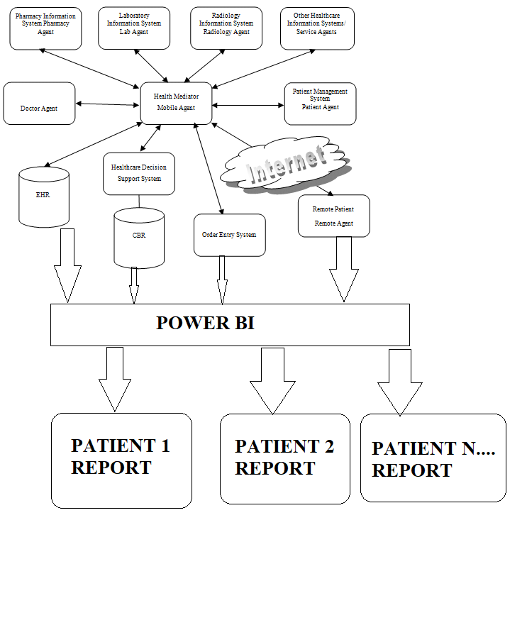

Fig no.1 System Architecture

The system architecture for healthcare report generation combines the robust backend capabilities of Django with the powerful visualization tools of Power BI. Django, acting as the data processing engine, interfaces with the healthcare database, retrieving and manipulating patient records and medical data through its ORM. The Django REST Framework exposes this data via secure APIs, enabling data extraction in formats compatible with Power BI, such as CSV or Parquet. Business logic within Django handles complex calculations and data aggregation, while asynchronous tasks, managed by Celery, ensure efficient processing of large datasets. Power BI then imports this prepared data, models it, and creates interactive reports and dashboards, offering users a comprehensive view of healthcare information.

PROPOSED METHODOLOGY
This system aims to simplify the task of the patient and the doctor .it will make patient more relaxed as they do not have to stand in a long queue to fix their appointment and also book an appointment according to their choice in a more convenient way. Doctor need not worry about managing their appointment. Though you are not going to clinic for taking an appointment, your appointment gets booked from anywhere and however you want. This helps to save the time of patient. Also the patient can get the doctor of his choice through various filters used in the application. The doctor is also able to view his day to day Appointment list which makes it easier for him..

Once the architecture is in place, the data integration and processing phase begins, where HMS data is synchronized with Power BI. This ensures that patient records, doctor schedules, billing details, inventory levels, and diagnostic reports are updated automatically.
Power BI's data transformation capabilities help refine and structure the information for meaningful insights. By leveraging automated reporting and mobile notifications, hospital staff can receive real-time alerts about critical events, such as high bed occupancy, inventory shortages, or financial irregularities, allowing them to take immediate action.IMAP

The final stage involves dashboard development, implementation, testing, and deployment. Custom Power BI dashboards are designed to provide intuitive visualizations, including patient statistics, revenue trends, and operational performance metrics. Testing is conducted to verify data accuracy, system performance, and security compliance before full deployment.

DATABASE DESIGN
The database design for the Django and Power BI healthcare report system prioritizes data integrity, efficiency, and scalability. It encompasses several interconnected tables, each serving specific purposes to facilitate comprehensive healthcare data management and reporting. At the core is the Patient table, storing demographic information like patient ID, name, date of birth, and contact details. This table establishes the foundational entity for all healthcare interactions. The MedicalRecord table links to Patient via a foreign key, holding crucial medical history, including diagnoses, allergies, and past treatments. To capture detailed medical assessments, the TestResult table stores results of various diagnostic tests, referencing Patient and linking to a TestType table that classifies tests (e.g., blood tests, imaging). The Diagnosis table holds diagnostic codes and descriptions, while the Treatment table tracks prescribed treatments, linking back to Patient and potentially to a Medication table for drug details. The Appointment table manages patient appointments, connecting to Patient and Doctor tables to record scheduling information.
For report generation, the database incorporates aggregated data tables. The PatientSummary table pre-calculates essential patient metrics, optimizing report query speeds. The DiseaseStatistics table aggregates disease prevalence and trends, supporting population health analyses. The TreatmentOutcome table stores treatment efficacy data, linking to Treatment and Patient to assess treatment effectiveness. To maintain data integrity, constraints, indexes, and relationships are carefully defined. For example, foreign keys enforce referential integrity, ensuring data consistency across tables.
.

INPUT DESIGN
The input design for our Django-based healthcare report system focuses on user-friendliness, data accuracy, and efficiency, catering to the needs of healthcare professionals and administrators. It incorporates a variety of input methods, ranging from structured forms to file uploads, ensuring seamless data entry and management. For patient registration, a comprehensive form captures essential demographic details, including name, date of birth, contact information, and medical history. This form employs data validation techniques, such as input masks and dropdown menus, to minimize errors and ensure data consistency. Medical test results are entered through standardized forms, allowing for the recording of numerical values, textual descriptions, and associated test types. File upload functionality is integrated to support the import of lab reports and imaging studies, enabling the system to handle diverse data formats.
Appointment scheduling is streamlined through an interactive calendar interface, allowing users to select dates, times, and doctors. The system incorporates real-time availability checks to prevent scheduling conflicts. For treatment planning, structured forms enable the input of prescribed medications, dosages, and treatment durations. These forms include features for linking treatments to specific diagnoses and patients, ensuring accurate record-keeping. Data entry for diagnoses is facilitated by searchable databases of medical codes, such as ICD-10, enabling users to quickly and accurately record patient conditions. The system also supports the input of patient feedback and treatment outcomes, allowing for the evaluation of treatment effectiveness.
To enhance data accuracy, the input design incorporates several validation mechanisms. Data type validation ensures that entered values conform to expected formats (e.g., numbers for test results, dates for appointments).

MODULE DESIGN

DATA FLOW DIAGRAMS

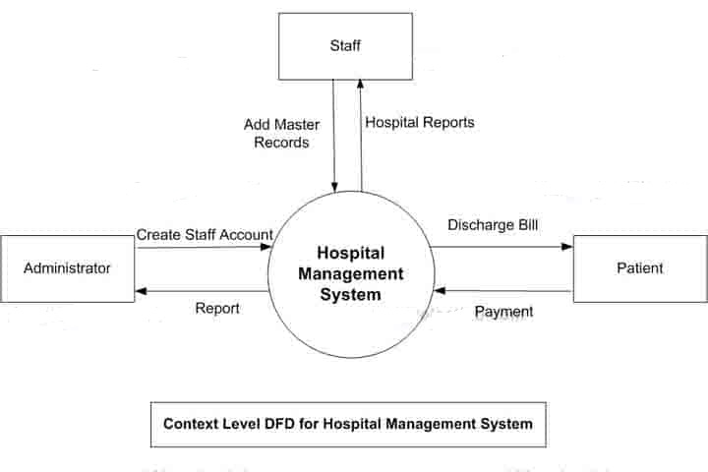
Fig no.2 Level 0 DFD

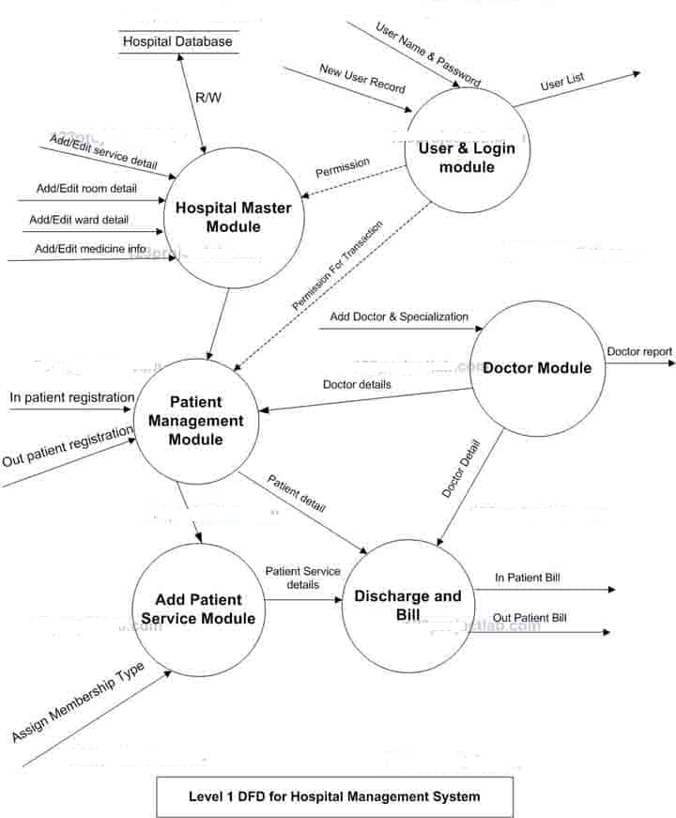

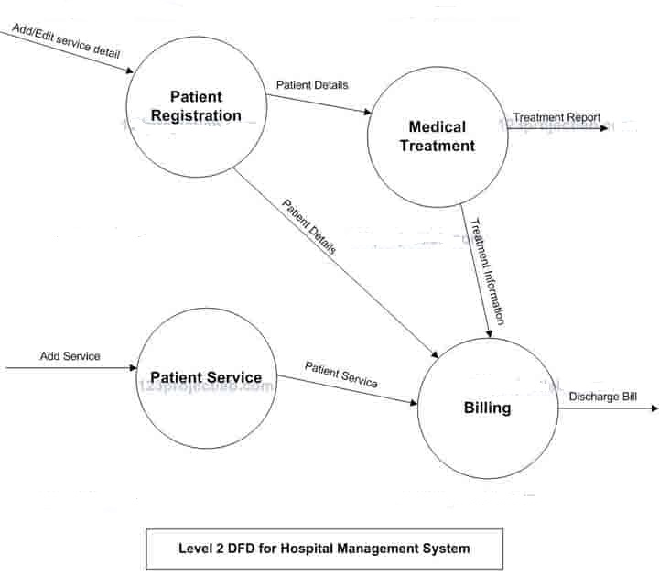

UML DIAGRAMS

Fig no. 5 Use Case Diagram

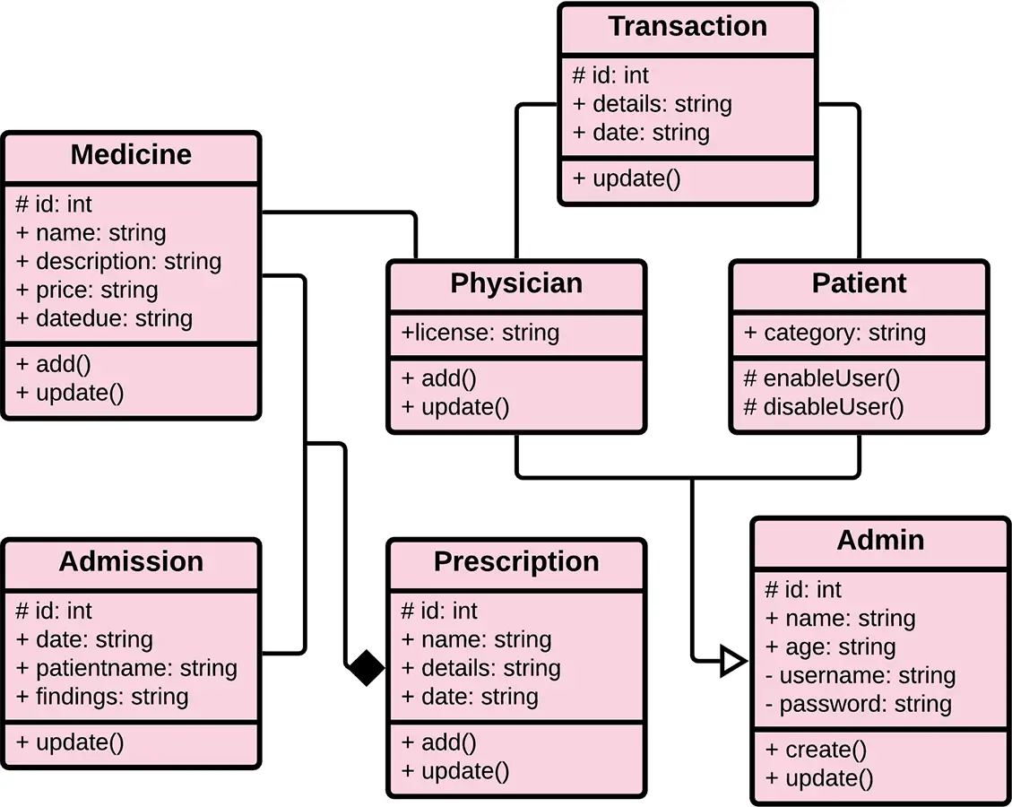
Fig no. 6 Class Diagram

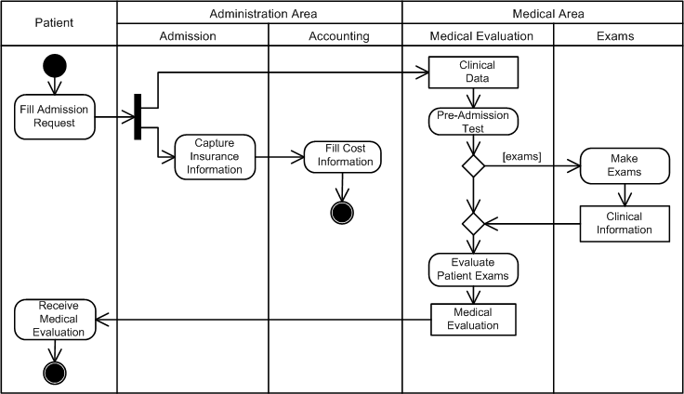

Fig no. 7 Activity Diagram

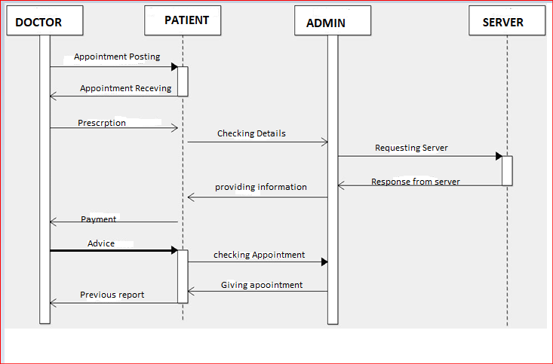

Fig no. 8 Sequence Diagram

CHAPTER 4 SYSTEM IMPLEMENTATION

HOME PAGE
It acts as the important and first module of the application. This page usually consists the inbox of all received messages. Any user who wants to use the application must register to gain username and password along with a code, first. The code is stored for a security purpose. Once the registration / login is done successfully, the user can perform the desired operations from the home page that the user wish to perform. The operations are done by voice commands. Additionally, this reduces the usage of keyboard shortcuts and mouse usage in the computer. The major options available are below:
    - Admin Login
    - Doctor Login
    - Patient Login

By reducing the use of shortcut ways or shortcut keys, the apply will provide the operation that needs to be performed for the services. All the mentioned functionalities were important for performing the basic application operations. As a concern towards the application usage in the system or mobile, the voice record mode will be activated on performing certain operations. This reduces the application background running, that reduce the diminishing of battery in the system.

ADMIN MODULE:
• In this section, Admin can view the Total Registered Doctors and Total Specializations.
• Admin can view doctor’s profile, their appointments and manage their patients list.
• Admin can view user’s detail and also have right to delete irrelevant user.
• Admin can view patient’s details.
• Admin can view appointment history.
• Admin can search doctor details by their name and mobile number.
• Admin can view reports of doctor in particular periods.
• Admin can update the website page details.
• Admin can search patient with the help of patient name and mobile number.
• Admin can also change’s his/her own password and profile..

PATIENT AND DOCTOR MODULE :
The Patient Module within our healthcare report system serves as the central hub for managing and accessing patient-related information, forming the cornerstone of the entire application. It's designed to provide a comprehensive and secure platform for healthcare professionals to efficiently handle patient data, from initial registration to ongoing medical management. This module emphasizes data integrity, accessibility, and user-friendliness, ensuring accurate and timely information for optimal patient care.
At its core, the Patient Module facilitates the creation and maintenance of detailed patient profiles. Upon registration, essential demographic data, including name, date of birth, contact information, and medical history, are meticulously recorded. The system employs rigorous data validation techniques, such as input masks and dropdown menus, to minimize errors and ensure consistency. Each patient is assigned a unique identifier, enabling seamless tracking across various medical interactions.
The module provides a centralized repository for medical records, allowing healthcare professionals to access patient diagnoses, allergies, past treatments, and current medications. This comprehensive view of a patient's medical history empowers informed decision-making and facilitates continuity of care. The system also integrates with other modules, such as the Appointment Module and the Test Result Module, enabling seamless access to scheduling information and diagnostic results.
Security and privacy are paramount within the Patient Module. Access to patient data is strictly controlled through user roles and permissions, ensuring that only authorized personnel can view or modify sensitive information. The system implements robust authentication and authorization mechanisms to prevent unauthorized access and maintain patient confidentiality. All data entry and modification activities are logged, providing an audit trail for accountability and compliance.

CHAPTER 5 RESULTS & DISCUSSION

TESTING

Software Testing is a critical element of software quality assurance and represents the ultimate review of specification, design and coding, Testing presents an interesting anomaly for the software engineer

Testing objectives

      - Testing is a process of executing a program with the intent of finding an error

      - A good test case is one that has a probability of finding an as yet undiscovered error

      - A successful test is one that uncovers an undiscovered error

Testing Principles
- All tests should be traceable to end user requirements

- Tests should be planned long before testing begins

- Testing should begin on a small scale and progress towards testing in large

- Exhaustive testing is not possible

- To be most effective testing should be conducted by a independent third party

    - TEST CASES

S.NO | Test Cases | Test  Procedure | Test Input | Expected  Result | Actual  Result
1 | Valid Login | - Enter a valid email address and password.  - Tap the “Login” button.  - Verify that the user is logged in successfully. | Valid email address | User should be logged in. | User should be logged in.
2 | Invalid Login | - Enter a invalid email address and password.  - Tap the “Login” button.  - Verify that the user is logged in  successfully. | Invalid email address | Error message should appear. | Error message should appear.
3 | Add patient | - Enter recipient email address and other individual data.  - Click time in & time out.  - Verify that amount is correct. | - Individual Information  - Symptoms  - Family details | Data should be stored. | Data should be stored

4 | Storing in sql | - Type Email address correctly  - Phone number should be in number  - Blood group will be in single or double character . | - Email Address  - Phone number  - Blood group | Successfully Stored in Mysql | Successfully Stored in Mysql
5 | Power BI Integration | - Giving correct DB  - Importing right Database with Table | - DB should be correct | DB imported correctly. | DB imported correctly..
6 | Database Connection | - Log in to the app.  - Verify that the app communicates  with the database. | Access with valid user credentials | Successful connection to the database. | Successful connection to the database.
7 | Invalid Database Credentials | - Modify the database credentials in the app configuration.  - Log in to the app.  - Verify that an appropriate error message is  displayed. | Unauthorized access | Error message related to database authentication should appear. | Error message related to database authentication should appear.

RESULT
The implementation of the Web-Based Hospital Management System has shown significant improvements in hospital operations. One of the key results is improved accessibility, allowing healthcare professionals to access the system from any location with internet connectivity. This feature has streamlined communication between departments, enabling real-time decision-making and improving service delivery. Additionally, patient management has become more efficient, with a centralized database that facilitates seamless patient registration, easy access to medical records, and better appointment scheduling. These improvements have led to reduced patient waiting times and a more organized workflow. The system has also enhanced billing and inventory management. By automating these processes, manual data entry errors have been minimized, increasing accuracy and reducing discrepancies in billing and inventory tracking. This has resulted in cost savings for the hospital. Another notable benefit is the scalability of the system, which allows hospitals to expand their operations without significant investments in new hardware. This, combined with the reduced need for hardware infrastructure, makes the system cost-effective and adaptable to future growth. Real-time data synchronization has further improved the accuracy of patient records and operational data, reducing the risk of errors and ensuring that information is always up-to-date. However, the reliance on internet connectivity poses a challenge in areas with unstable networks, which may disrupt the availability of real-time data. Furthermore, while the system reduces hardware costs, there is a need for robust cybersecurity measures to protect sensitive patient information. In conclusion, the Web-Based Hospital Management System offers an effective solution for improving hospital operations, enhancing patient care, and increasing administrative efficiency. Its flexibility, scalability, and centralized data management make it a valuable asset for modern healthcare .

CHAPTER 6 CONCLUSION & FUTURE SCOPE

FUTURE SCOPE

Predictive Analytics for Patient Flow: Implement machine learning models within the Django backend to predict patient arrival patterns, bed occupancy, and emergency room traffic. Integrate these predictions into Power BI dashboards for real-time visualization, enabling proactive resource allocation and reducing patient wait times.
B. Personalized Patient Care Dashboards: Develop Power BI dashboards that provide personalized insights into patient health trends, medication adherence, and treatment outcomes. Enable patients to access these dashboards through secure web portals, fostering greater engagement in their care.
C. Telemedicine Integration & Remote Monitoring: Expand the system to include telemedicine functionalities, allowing remote consultations and patient monitoring. Integrate sensor data from wearable devices and home monitoring equipment into the Django backend, and visualize trends and anomalies in Power BI dashboards for proactive intervention.
D. Advanced Inventory Management & Supply Chain Analytics: Leverage Power BI to analyze hospital inventory data, track medication usage, and predict supply shortages. Implement automated alerts and visualizations to optimize procurement processes and reduce waste.
E. Financial Performance & Operational Efficiency Analysis: Integrate financial data from billing, insurance, and operational systems into Power BI to provide comprehensive insights into hospital revenue, expenses, and operational efficiency. Develop interactive dashboards to identify cost-saving opportunities and improve resource utilization.

CONCLUSION
In summary, the advantages offered by each module of the Hospital Management System culminate in a cohesive, efficient, and patient-focused healthcare environment. By minimizing administrative overhead, enhancing communication among stakeholders, and improving data management, an HMS not only optimizes internal operations but also elevates the quality of care delivered to patients. The integration of technology in healthcare management is essential for adapting to the evolving demands of the industry, ensuring that hospitals can provide high-quality services in an increasingly complex healthcare landscape. As hospitals continue to embrace digital transformation, the implementation of a comprehensive Hospital Management System stands out as a strategic investment. It not only meets the immediate needs of operational efficiency but also positions healthcare facilities for future growth and innovation, ultimately leading to better health outcomes and enhanced patient satisfaction.

APPENDICES

APPENDIX 1 : SDG GOALS
• Improved Healthcare Access and Quality (SDG 3):
- Power BI dashboards provide real-time insights into patient flow, bed occupancy, and resource utilization, enabling hospitals to optimize operations and reduce wait times. This leads to more efficient and timely healthcare delivery.
- Telemedicine integration and remote monitoring functionalities extend healthcare access to underserved populations, particularly those in remote areas or with mobility limitations.
- AI-powered diagnostic assistance and clinical decision support tools enhance diagnostic accuracy and treatment effectiveness, contributing to better patient outcomes.
• Reduced Healthcare Disparities (SDG 10):
- Multilingual patient interaction and data entry features ensure that language barriers do not impede access to quality healthcare.
- Personalized patient care dashboards empower patients to actively participate in their health management, regardless of their socioeconomic background.
- Telemedicine integration, as stated above, can give access to people that would otherwise not have access to medical care.
- The system can track and report on healthcare disparities based on factors like location, income, and ethnicity, enabling hospitals and policymakers to address inequalities. Power BI, used with the system, can display this data in easy to understand ways.
• Enhanced Data-Driven Decision Making (SDG 3 & 10):
- Power BI's visualization capabilities enable hospitals to analyze large datasets and identify trends in patient outcomes, resource utilization, and operational efficiency.
- This data-driven approach supports evidence-based decision-making, leading to improved healthcare policies and resource allocation, particularly for vulnerable populations.
- By tracking and visualizing health disparities, the system supports efforts to reduce inequalities in healthcare access and outcomes.

APPENDIX 2 : SOURCE CODE
from django.shortcuts import render,redirect,HttpResponse
from dasapp.EmailBackEnd import EmailBackEnd
from django.contrib.auth import logout,login
from django.contrib import messages
from django.contrib.auth.decorators import login_required
from dasapp.models import CustomUser
from django.contrib.auth import get_user_model
User = get_user_model()
def BASE(request):
return render(request,'base.html')

def LOGIN(request):
return render(request,'login.html')

def doLogout(request):
logout(request)
return redirect('login')

def doLogin(request):
if request.method == 'POST':
user = EmailBackEnd.authenticate(request,
username=request.POST.get('email'),
password=request.POST.get('password')
)
if user!=None:
login(request,user)
user_type = user.user_type
if user_type == '1':
return redirect('admin_home')
elif user_type == '2':
return redirect('doctor_home')
elif user_type == '3':
return redirect('userhome')

else:
messages.error(request,'Email or Password is not valid')
return redirect('login')
else:
messages.error(request,'Email or Password is not valid')
return redirect('login')

login_required(login_url='/')
def PROFILE(request):
user = CustomUser.objects.get(id = request.user.id)
context = {
"user":user,
}
return render(request,'profile.html',context)
@login_required(login_url = '/')
def PROFILE_UPDATE(request):
if request.method == "POST":
profile_pic = request.FILES.get('profile_pic')
first_name = request.POST.get('first_name')
last_name = request.POST.get('last_name')
email = request.POST.get('email')
username = request.POST.get('username')
print(profile_pic)

try:
customuser = CustomUser.objects.get(id = request.user.id)
customuser.first_name = first_name
customuser.last_name = last_name

if profile_pic !=None and profile_pic != "":
customuser.profile_pic = profile_pic
customuser.save()
messages.success(request,"Your profile has been updated successfully")
return redirect('profile')

except:
messages.error(request,"Your profile updation has been failed")
return render(request, 'profile.html')

def CHANGE_PASSWORD(request):
context ={}
ch = User.objects.filter(id = request.user.id)

if len(ch)>0:
data = User.objects.get(id = request.user.id)
context["data"]:data
if request.method == "POST":
current = request.POST["cpwd"]
new_pas = request.POST['npwd']
user = User.objects.get(id = request.user.id)
un = user.username
check = user.check_password(current)
if check == True:
user.set_password(new_pas)
user.save()
messages.success(request,'Password Change Succeesfully!!!')
user = User.objects.get(username=un)
login(request,user)
else:
messages.success(request,'Current Password wrong!!!')
return redirect("change_password")
return render(request,'change-password.html')
"""
URL configuration for docappsystem project.

The `urlpatterns` list routes URLs to views. For more information please see:
https://docs.djangoproject.com/en/5.0/topics/http/urls/
Examples:
Function views
1. Add an import: from my_app import views
2. Add a URL to urlpatterns: path('', views.home, name='home')
Class-based views
1. Add an import: from other_app.views import Home
2. Add a URL to urlpatterns: path('', Home.as_view(), name='home')
Including another URLconf
1. Import the include() function: from django.urls import include, path
2. Add a URL to urlpatterns: path('blog/', include('blog.urls'))
"""
from django.contrib import admin
from django.urls import path
from .import views,adminviews,docviews,userviews
from django.conf.urls.static import static
from django.conf import settings

urlpatterns = [
path('admin/', admin.site.urls),
path('base/', views.BASE, name='base'),
path('login', views.LOGIN, name='login'),

path('doLogin', views.doLogin, name='doLogin'),
path('doLogout', views.doLogout, name='logout'),

# This is admin panel
path('Admin/AdminHome', adminviews.ADMINHOME, name='admin_home'),
path('Admin/Specialization', adminviews.SPECIALIZATION, name='add_specilizations'),
path('Admin/ManageSpecialization', adminviews.MANAGESPECIALIZATION, name='manage_specilizations'),
path('Admin/DeleteSpecialization/<str:id>', adminviews.DELETE_SPECIALIZATION, name='delete_specilizations'),
path('UpdateSpecialization/<str:id>', adminviews.UPDATE_SPECIALIZATION, name='update_specilizations'),
path('UPDATE_Specialization_DETAILS', adminviews.UPDATE_SPECIALIZATION_DETAILS, name='update_specilizations_details'),
path('Admin/DoctorList', adminviews.DoctorList, name='viewdoctorlist'),
path('Admin/ViewDoctorDetails/<str:id>', adminviews.ViewDoctorDetails, name='viewdoctordetails'),
path('Admin/ViewDoctorAppointmentList/<str:id>', adminviews.ViewDoctorAppointmentList, name='viewdoctorappointmentlist'),
path('Admin/ViewDOCPatient/<str:id>', adminviews.View_DOCPatient, name='viewdocpatient'),
path('Admin/ViewCheckPatient/<str:id>', adminviews.ViewCheckAddPatient, name='viewcheckaddpatient'),

path('Admin/ViewPatientDetails/<str:id>', adminviews.ViewPatientDetails, name='viewpatientdetails'),
path('SearchDoctor', adminviews.Search_Doctor, name='search_doctor'),
path('Admin/RegUsers', adminviews.RegUsersDetails, name='regusers'),
path('Admin/DeleteRegusers/<str:id>', adminviews.DELETE_REGUSERS, name='delusersdetails'),
path('Admin/RegUserAppointment/<str:id>', adminviews.Reg_User_Appoinments, name='regusersapp'),

path('DoctorBetweenDateReport', adminviews.Doctor_Between_Date_Report, name='doctor_between_date_report'),

#Website Page
path('Website/update', adminviews.WEBSITE_UPDATE, name='website_update'),
path('UPDATE_WEBSITE_DETAILS', adminviews.UPDATE_WEBSITE_DETAILS, name='update_website_details'),

# This is Doctor Panel
path('docsignup/', docviews.DOCSIGNUP, name='docsignup'),
path('Doctor/DocHome', docviews.DOCTORHOME, name='doctor_home'),
path('Doctor/AddPatient', docviews.Add_Patient, name='add_patient'),
path('Doctor/ManagePatient', docviews.Manage_Patient, name='manage_patient'),
path('Doctor/ViewPatient/<str:id>', docviews.View_Patient, name='viewpatient'),
path('Doctor/EditPatient', docviews.edit_patient, name='editpatient'),
path('Doctor/ViewCheckPatient/<str:id>', docviews.ViewCheckPatient, name='viewcheckpatient'),
path('Doctor/UpdateMedRecPatient', docviews.update_med_rec_patient, name='updatemedrecpatient'),
path('Doctor/ViewAppointment', docviews.View_Appointment, name='view_appointment'),
path('DoctorPatientAppointmentDetails/<str:id>', docviews.Patient_Appointment_Details, name='patientappointmentdetails'),
path('AppointmentDetailsRemark/Update', docviews.Patient_Appointment_Details_Remark, name='patient_appointment_details_remark'),
path('DoctorPatientApprovedAppointment', docviews.Patient_Approved_Appointment, name='patientapprovedappointment'),
path('DoctorPatientCancelledAppointment', docviews.Patient_Cancelled_Appointment, name='patientcancelledappointment'),
path('DoctorPatientNewAppointment', docviews.Patient_New_Appointment, name='patientnewappointment'),
path('DoctorPatientListApprovedAppointment', docviews.Patient_List_Approved_Appointment, name='patientlistappointment'),
path('DoctorAppointmentList/<str:id>', docviews.DoctorAppointmentList, name='doctorappointmentlist'),
path('PatientAppointmentPrescription', docviews.Patient_Appointment_Prescription, name='patientappointmentprescription'),
path('PatientAppointmentCompleted', docviews.Patient_Appointment_Completed, name='patientappointmentcompleted'),
path('SearchAppointment', docviews.Search_Appointments, name='search_appointment'),
path('SearchPatient', docviews.Search_Patient, name='search_patient'),
path('BetweenDateReport', docviews.Between_Date_Report, name='between_date_report'),
path('BetweenDatePatientReport', docviews.Between_Date_Patient_Report, name='between_date_patient_report'),

#This is User Panel
path('PatientRegsitratios', userviews.PATIENTREGISTRATION, name='patreg'),
path('Pat/PatHome', userviews.PATIENTHOME, name='userhome'),
path('userbase/', userviews.USERBASE, name='userbase'),

APPENDIX 3 : SCREEN SHOTS

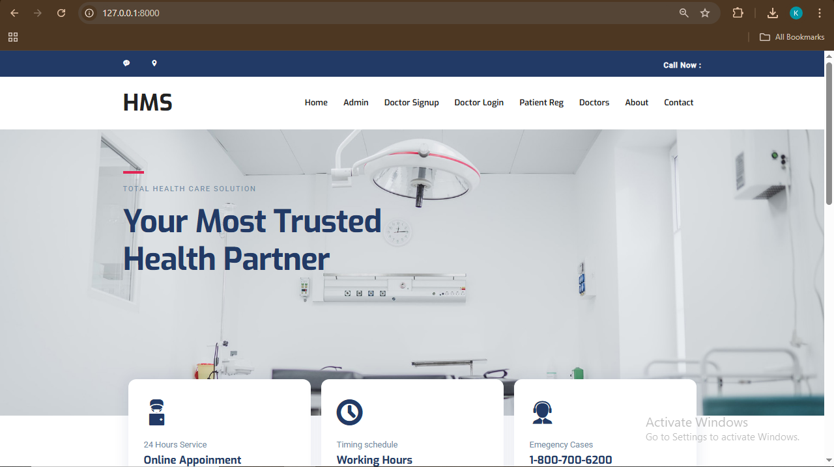

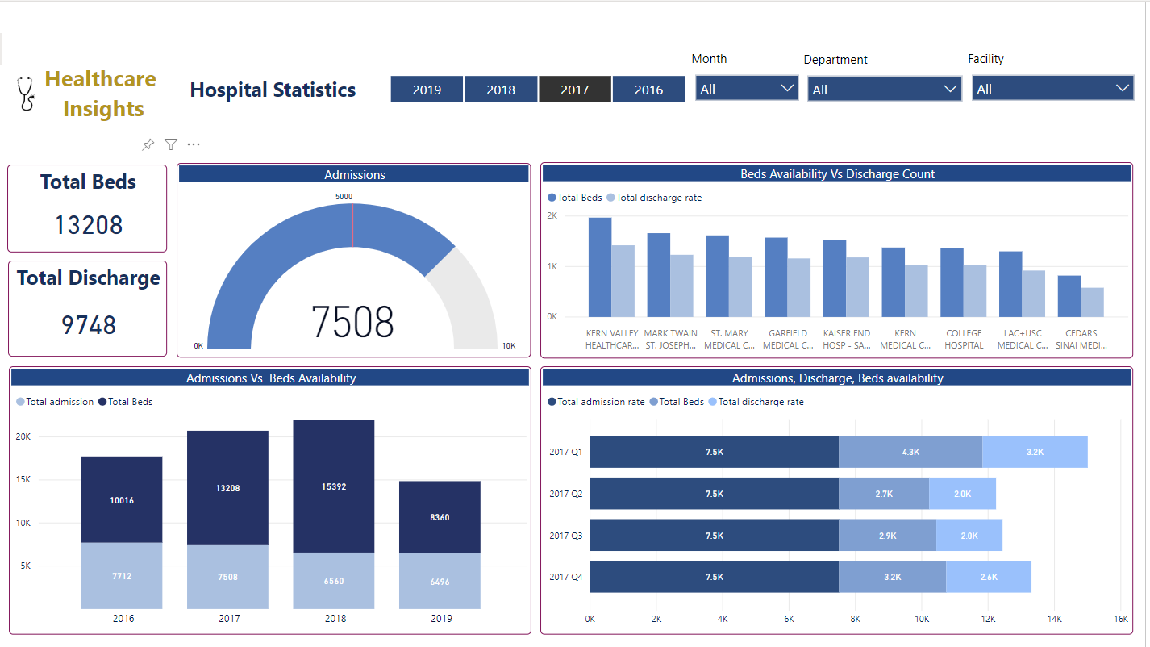

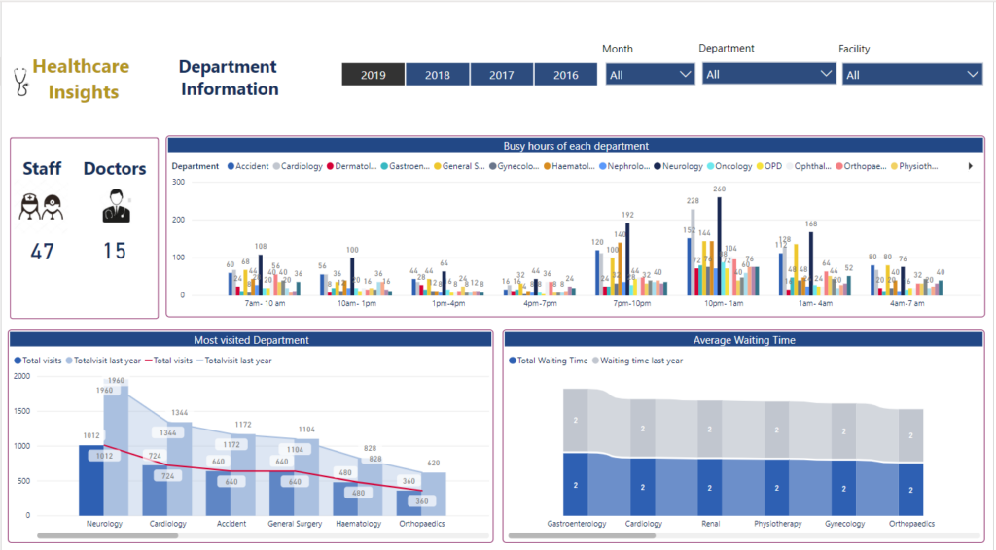

APEENDIX 4 : PAPER PLAGIARISM REPORT
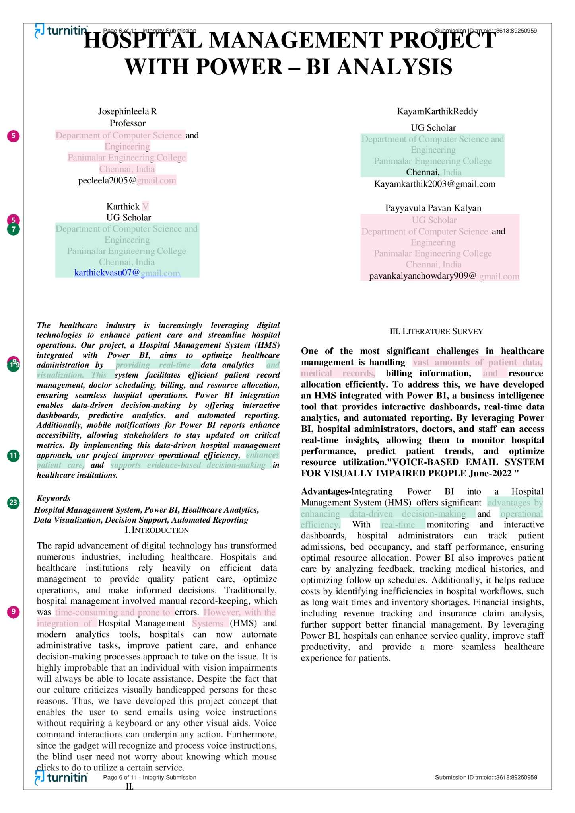

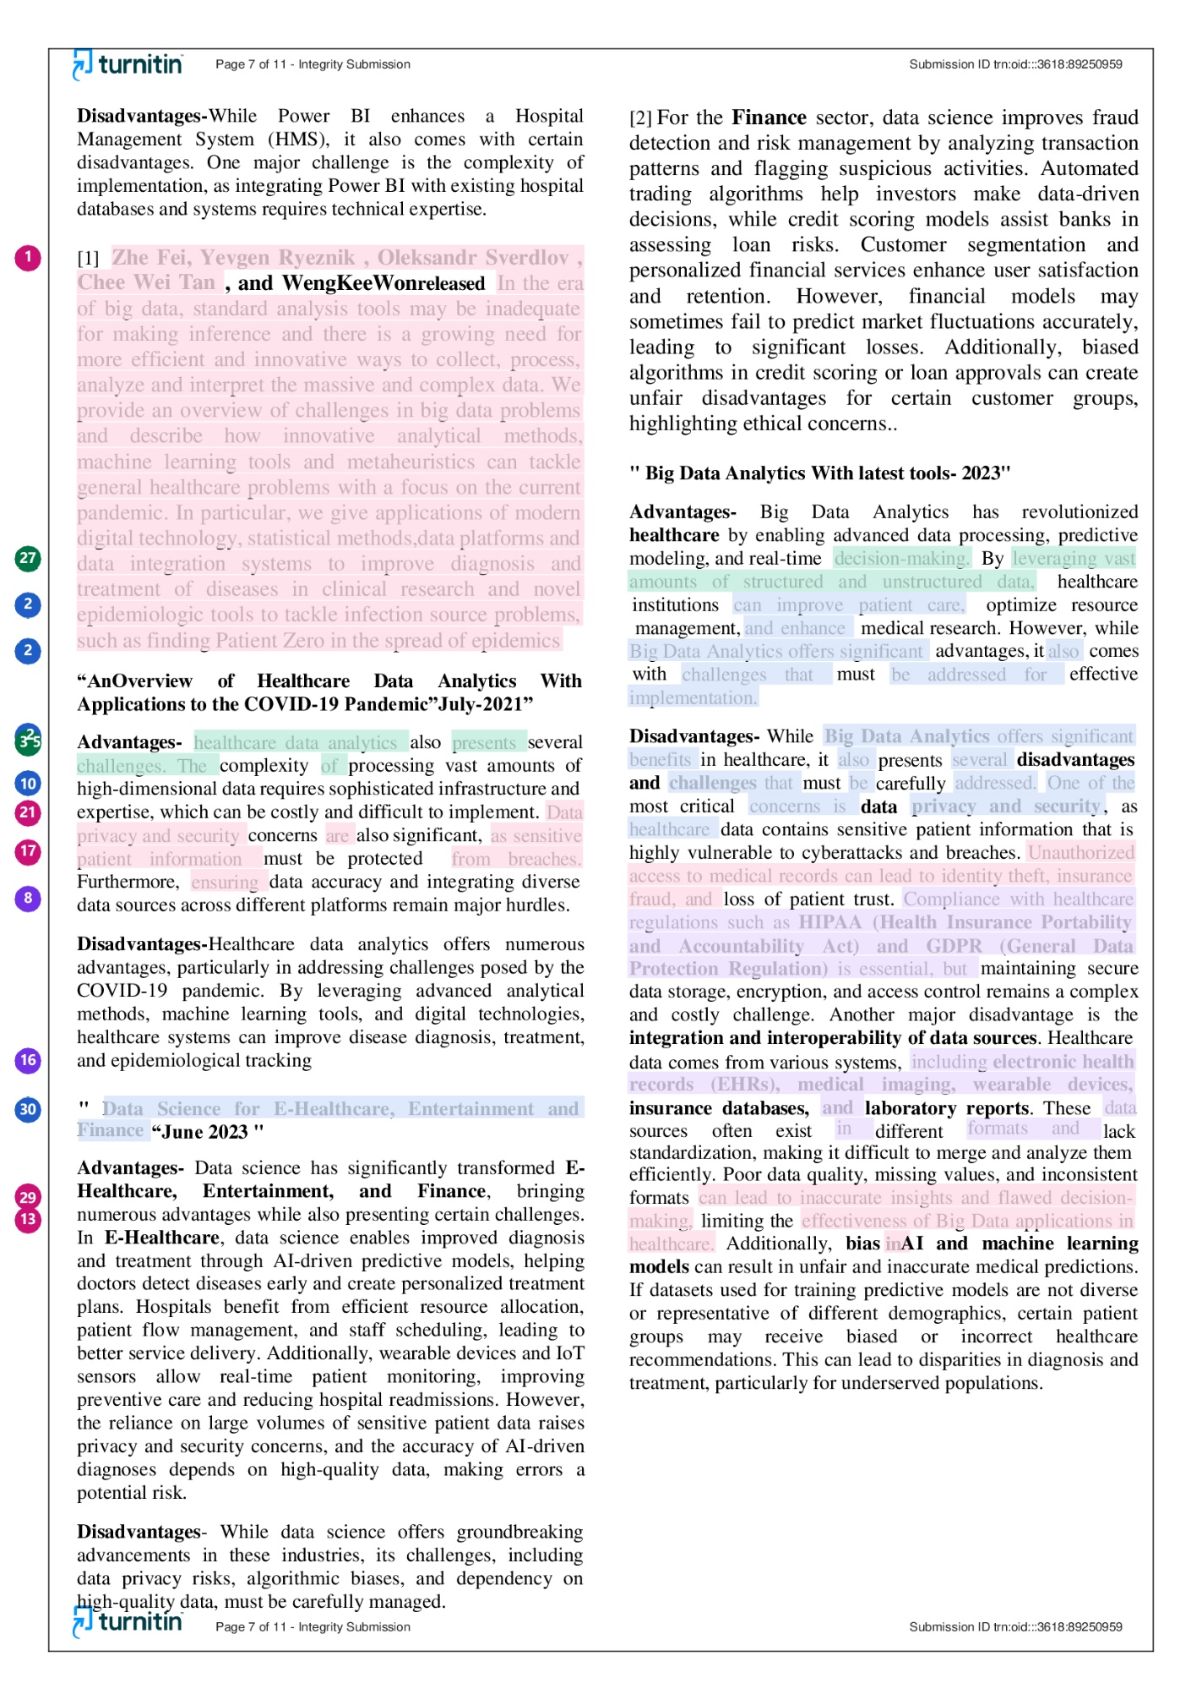

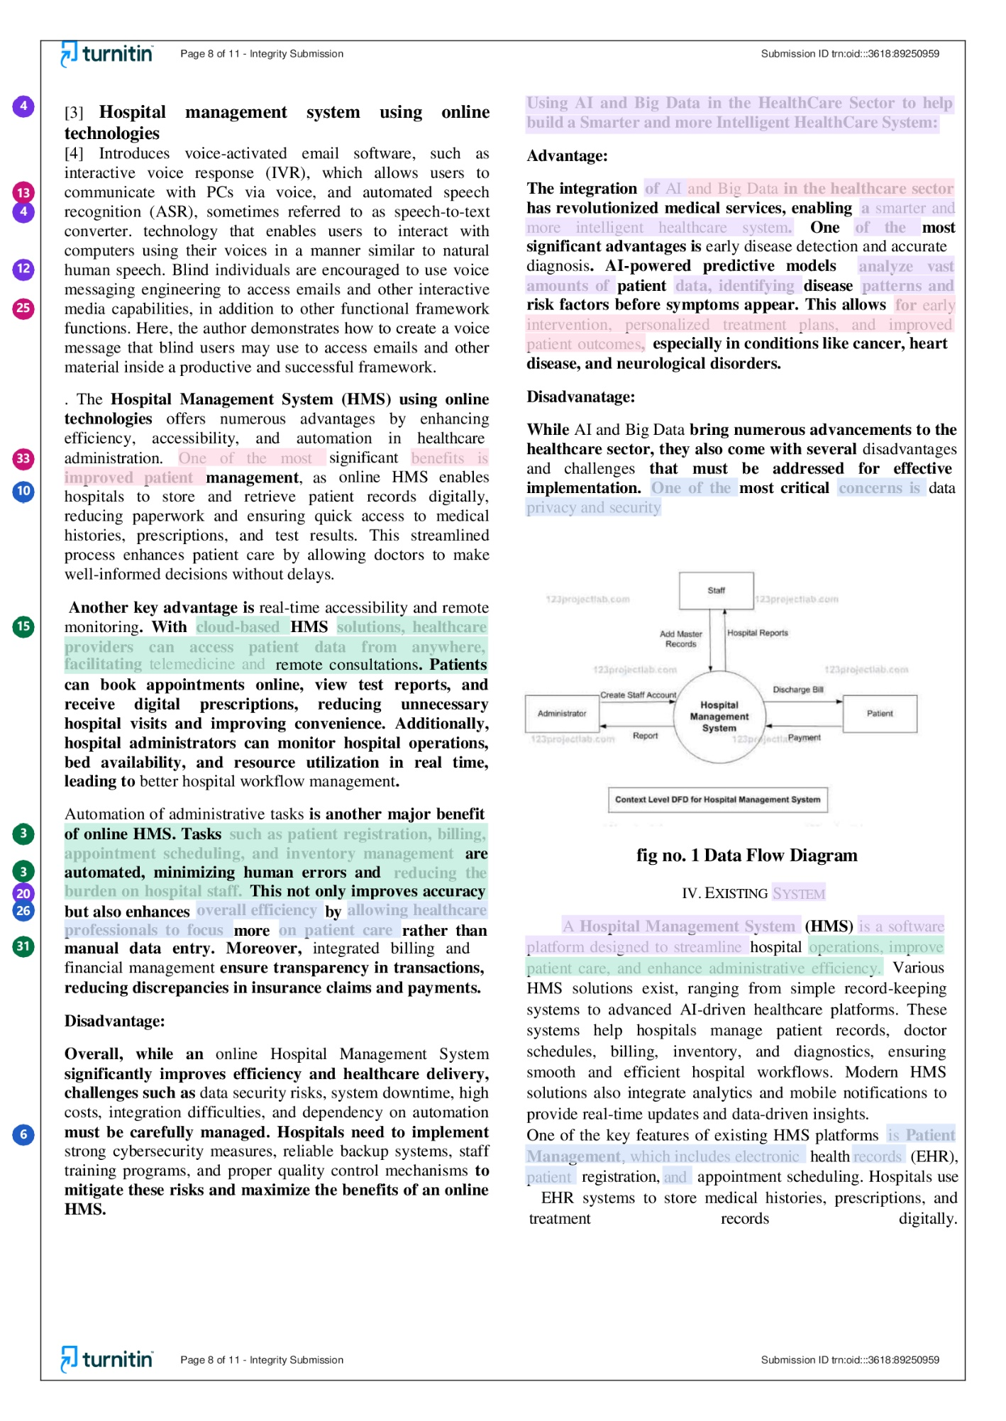

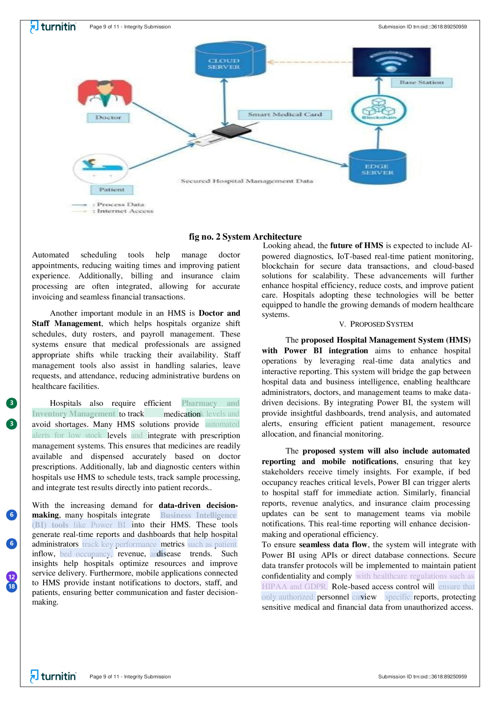

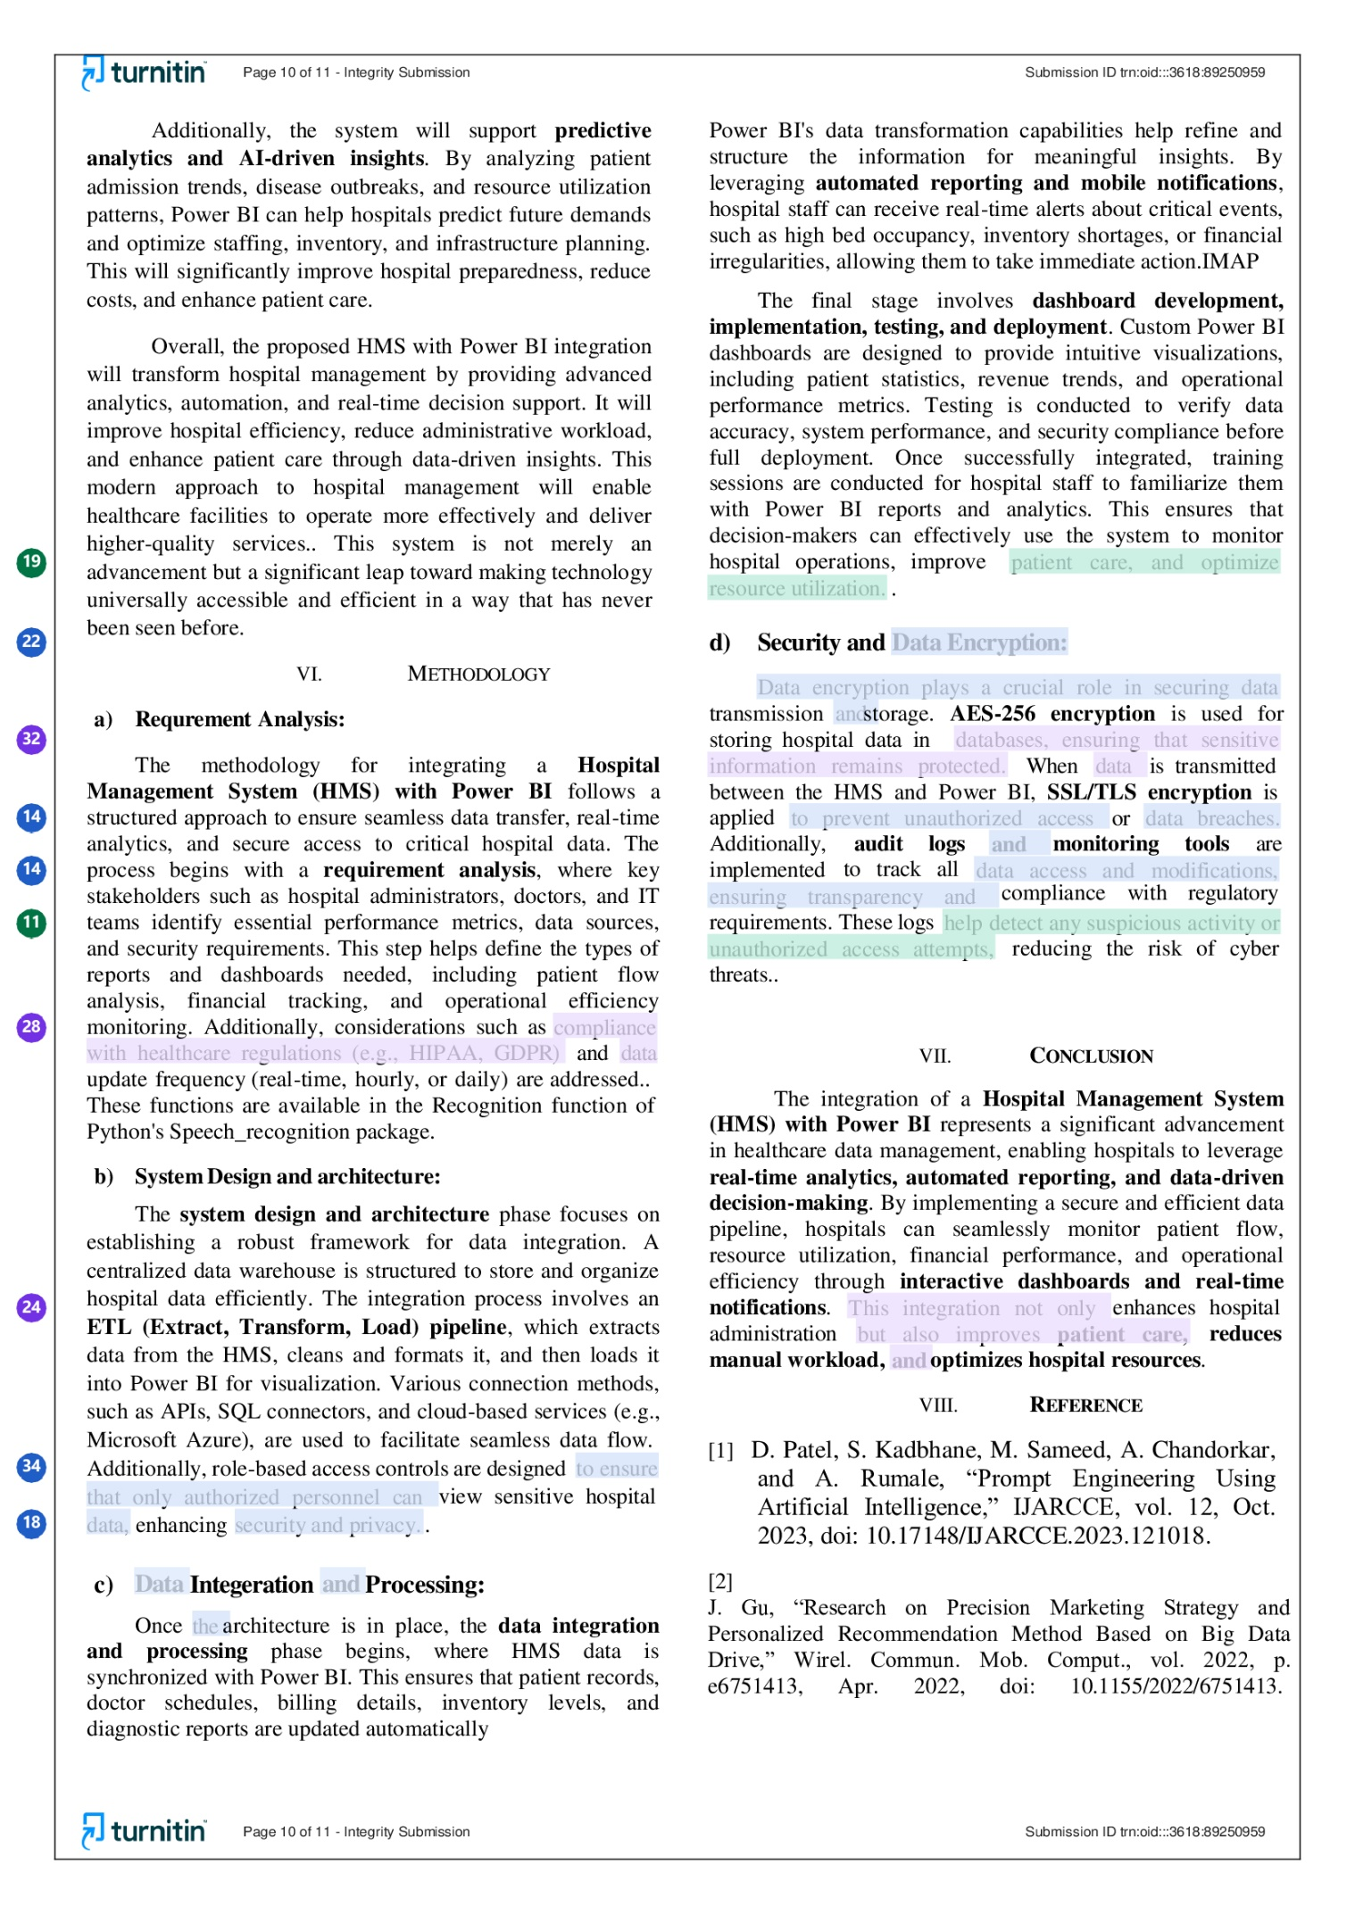

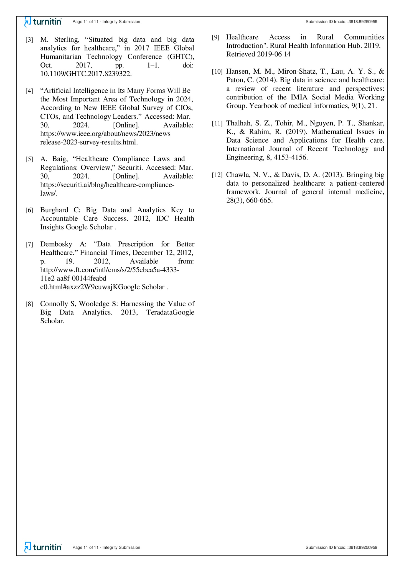

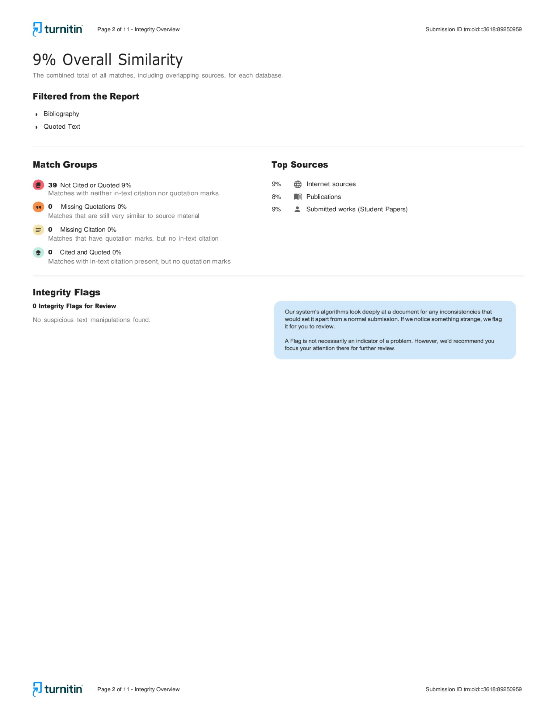

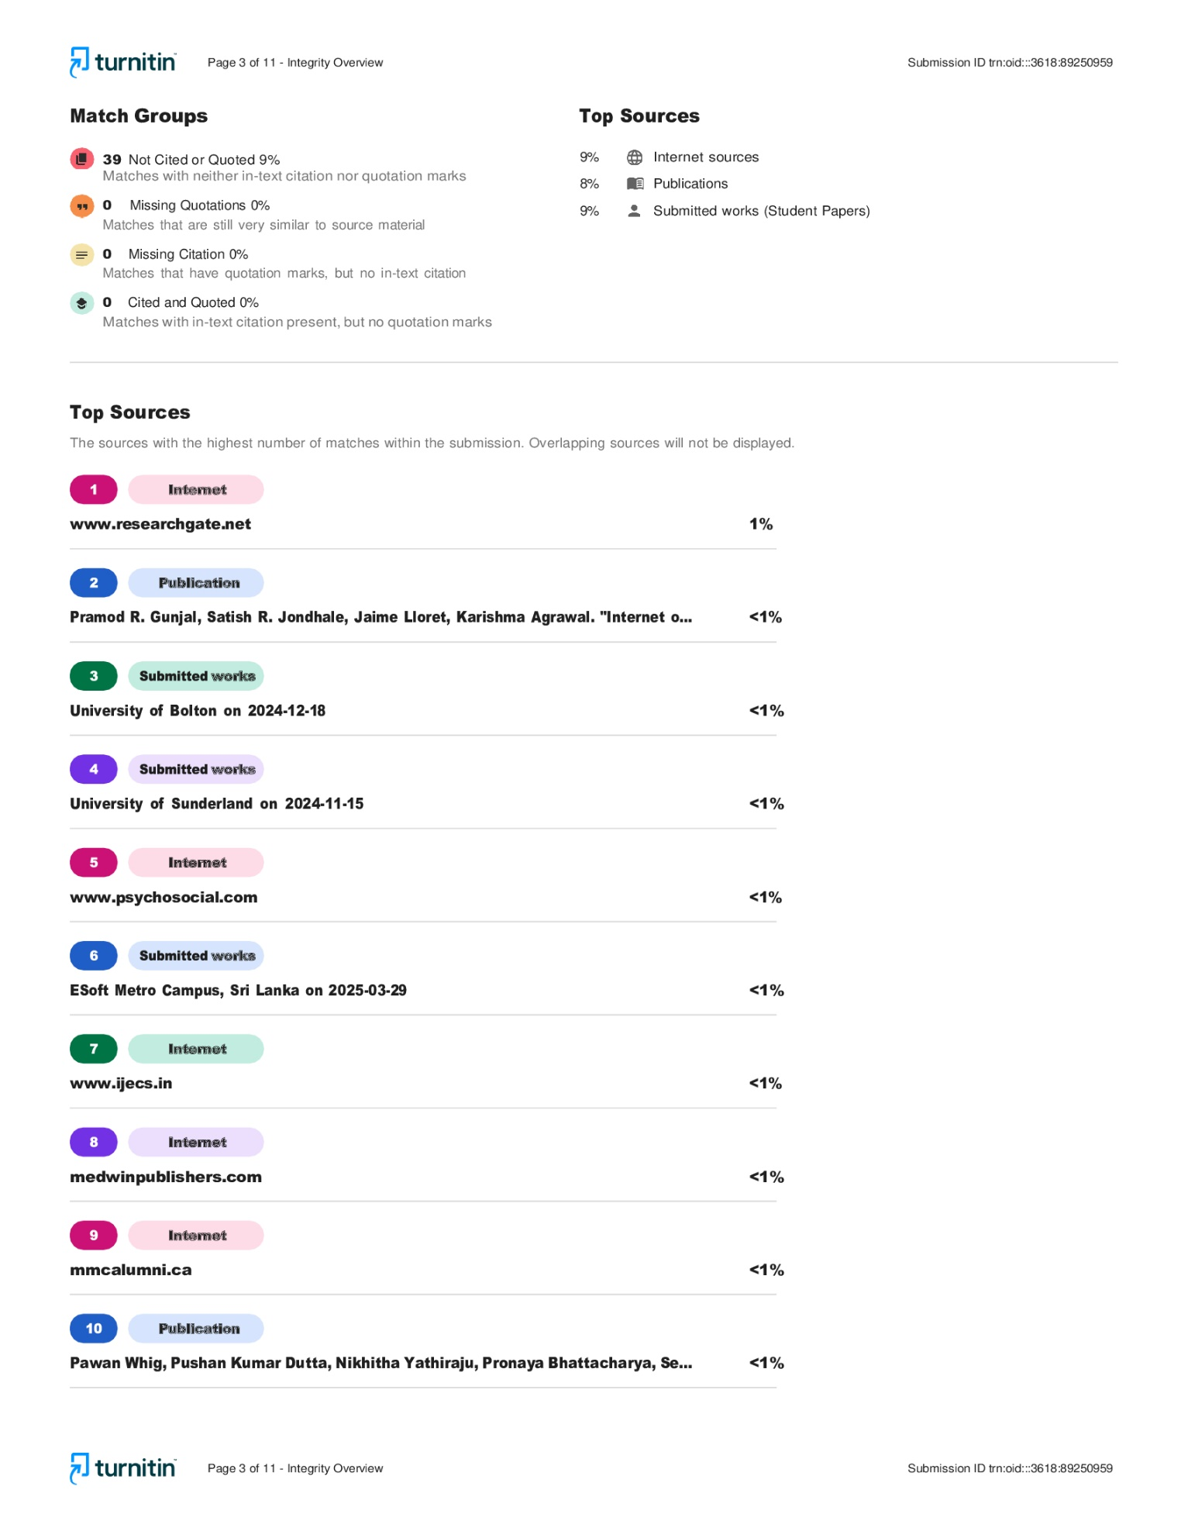

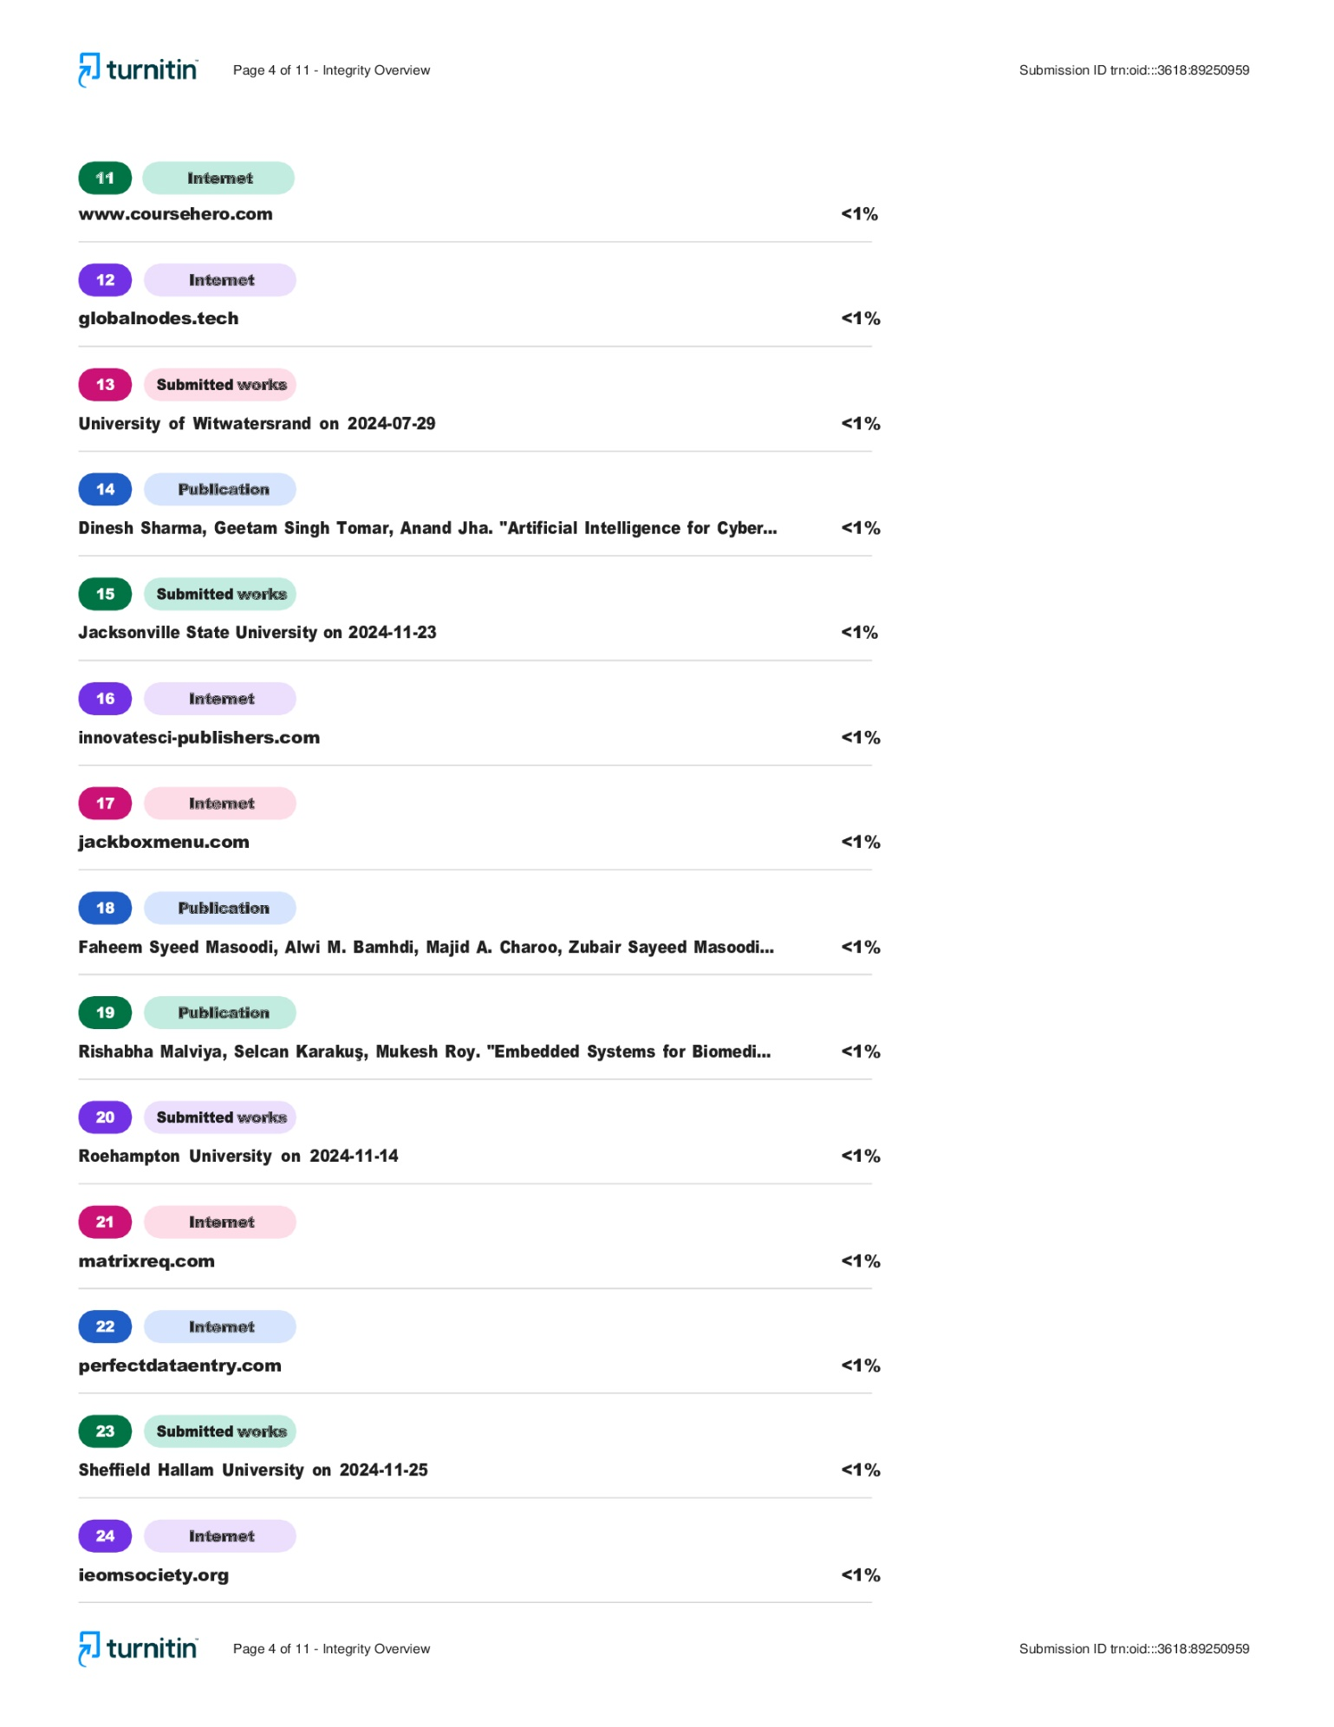

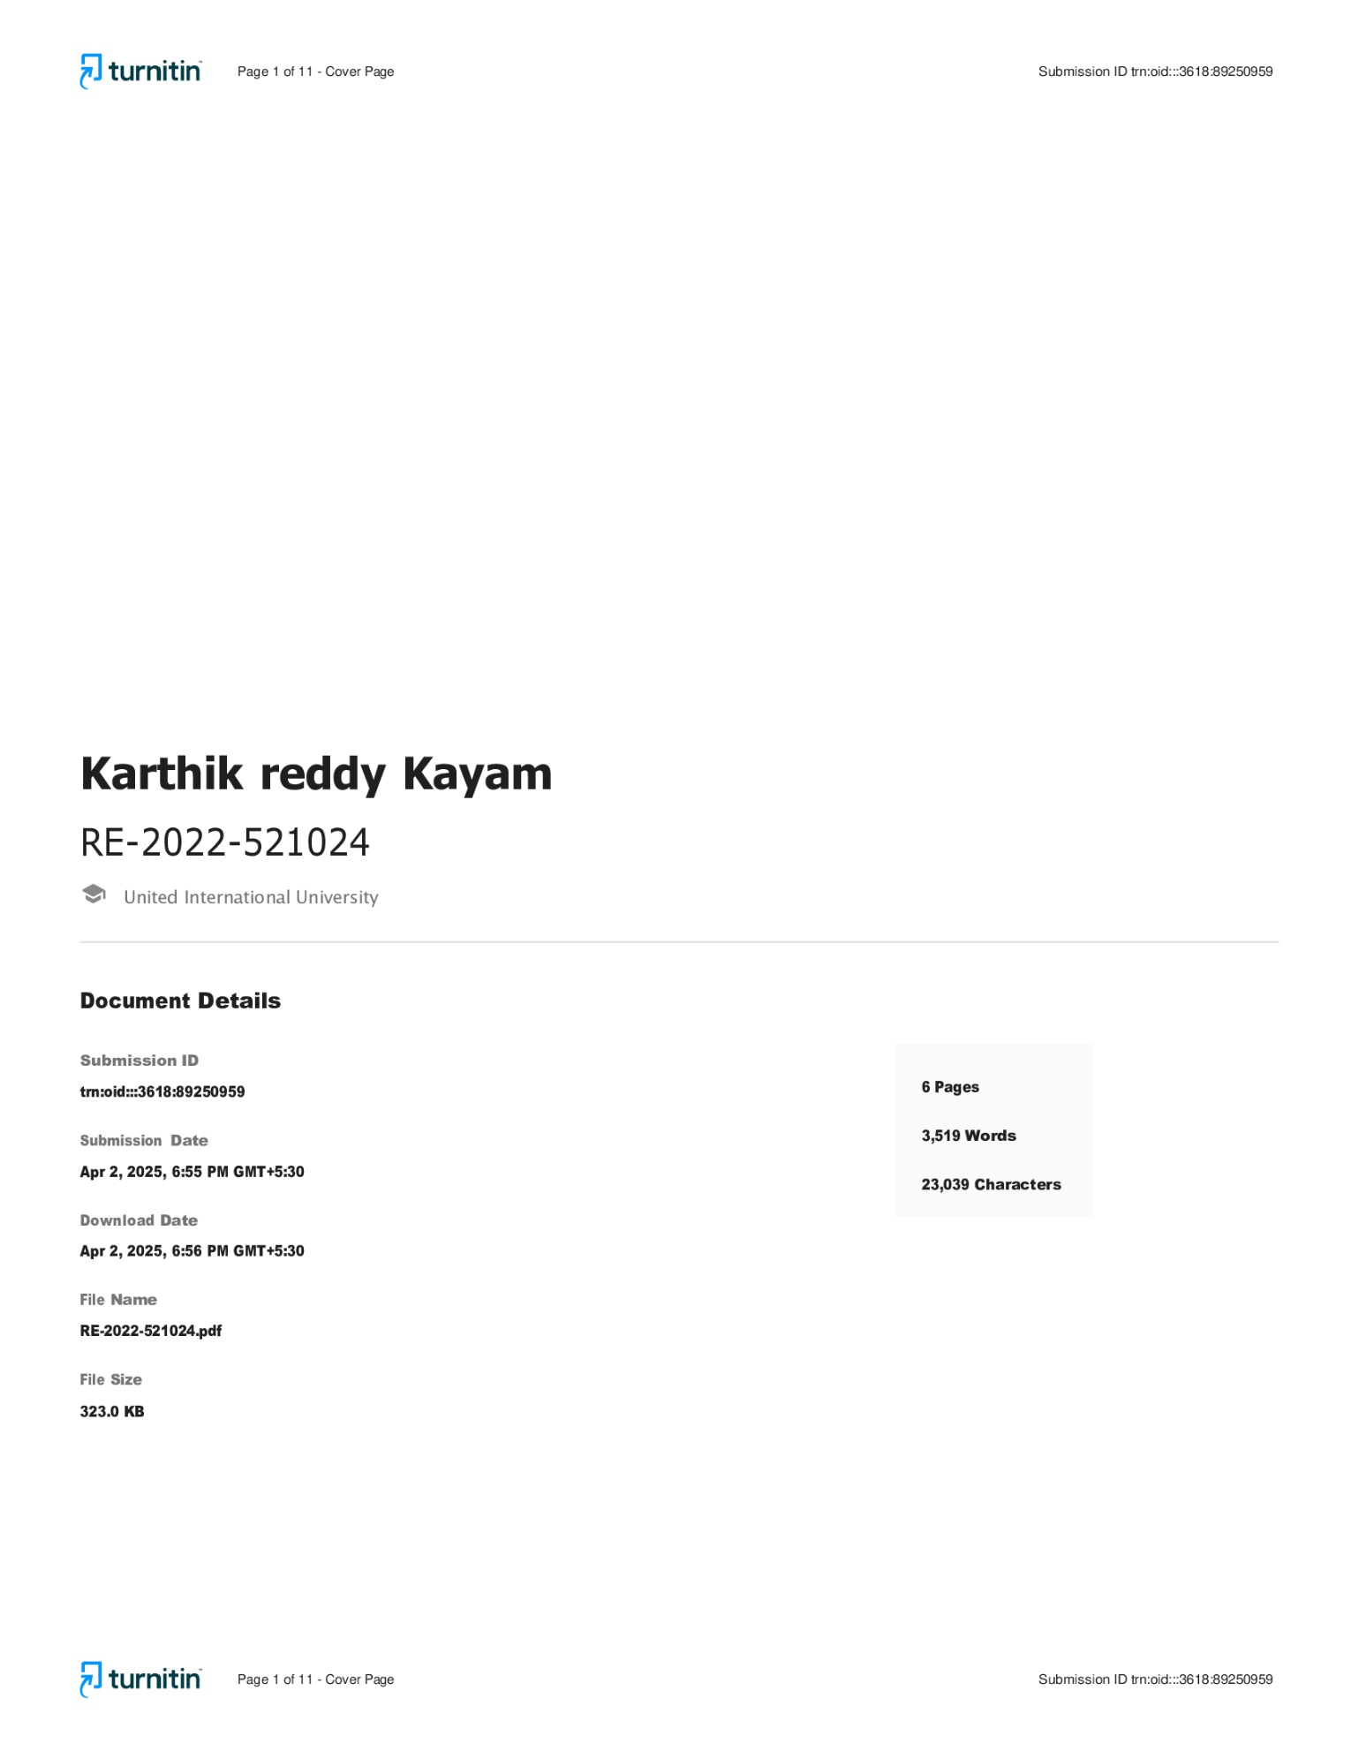

REFERENCE :
Park, Y. J., & Kim, M. S. (2020). Development of an ID card generation system using smart card technology. Journal Security Engineering, 17(2), 39-48.
[2] Asua, J., et al. (2019). "Implementing a Hospital Information System: A Cross-Case Analysis at Eight Hospitals." HInformatics Journal, 25(2), 84-97. Journal of Advanced Computer Science and Applications, 11(3), 203 209.
[3] Majeed, R. W., & Qureshi, A. H. (2019). "Healthcare Information Systems: A Review of Their Functions, Features and Operations." Journal of Healthcare Engineering, 2019.
[4] Kim, Y., Kang, H., & Lee, S. (2019). Development of an ID card generation system with biometric authentication. Action Processing Systems, 15(1), 19 28.
[5] Kuo, K. M., & Talley, P. C. (2018). "Toward a contextualized and integrated approach to hospital information system adoption: Insights from organizational field’s theory." Health Informatics Journal, 24(4), 270-284.
[6] Web Development with Django by Ben Shaw, Saurabh, Django 4 By Example by Antonio Mele. © 2024, IJSREM | www.ijsrem.com

[7] “Artificial Intelligence in Its Many Forms Will Be the Most Important Area of Technology in 2024, According to New IEEE Global Survey of CIOs, CTOs, and Technology Leaders.” Accessed: Mar. 30, 2024. [Online]. Available: https://www.ieee.org/about/news/2023/news release-2023-survey-results.html.
[8] A. Baig, “Healthcare Compliance Laws and Regulations: Overview,” Securiti. Accessed: Mar. 30, 2024. [Online]. Available:

